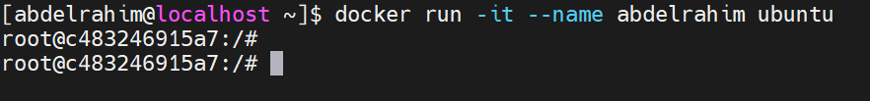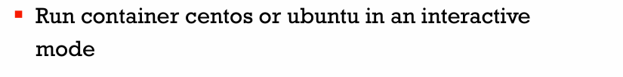

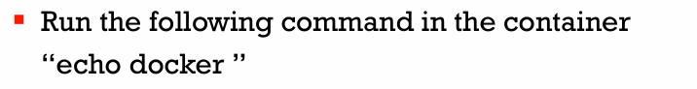



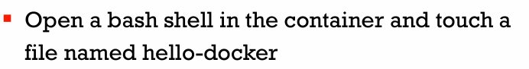

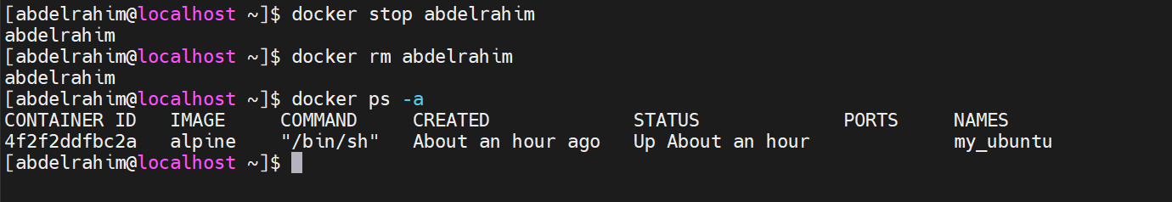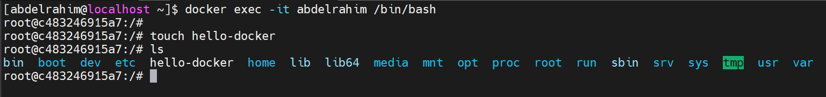

**Noted:** the file ( hello-docker ) delete with the container, The file ( hello-docker ) was created inside the container's filesystem .



